CrowdFunding vs Regulation A vs Regualtion D 506(b)

[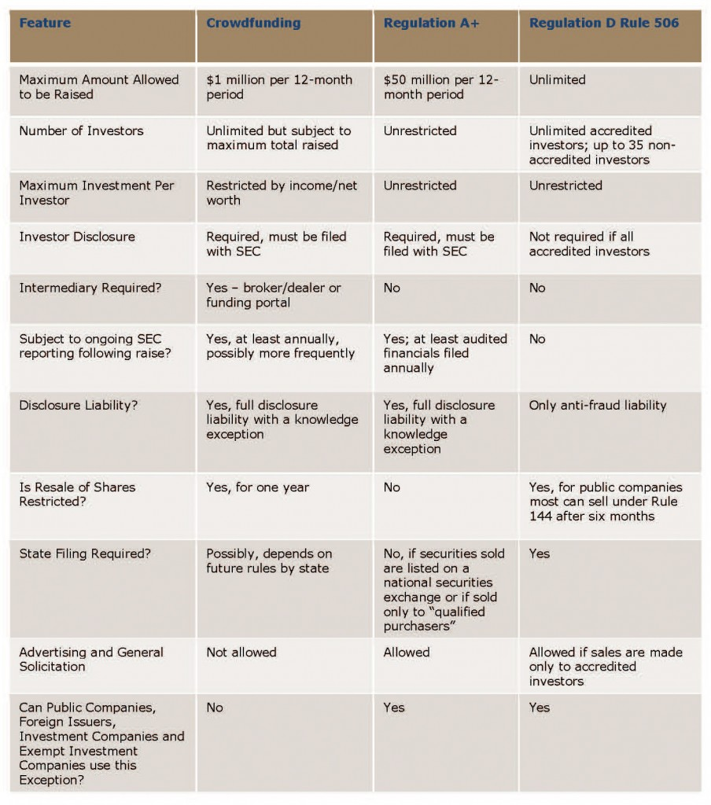](http://b-i.forbesimg.com/deborahljacobs/files/2013/04/CrowdfundingArticlechart_BrianKorn4.jpg)